Angular Setup--

NodeJS

- Open-source run-time environment built on Chrome’s V8 JS engine used to execute JS outside a web browser. We need this in order to run Angular apps.
- It provides a large library of various JS modules which can simplify development for web applications.
- NodeJS has been used for development by many large companies including: Netflix, Facebook, Walmart, Linkedin, Uber etc.
  - It has helped companies create various applications like social media apps, video/text chat engines, web browser-based games, and collaboration tools.

Node Package Manager (npm)

- This is Node’s built-in package manager. It is similar to things like Scoop or Homebrew and allows for downloading and installing libraries for development.
- “Angular and its dependencies are installed with npm and runs on a NodeJS environment (server) which is why we need them” -Good start to an answer in QC
- CLI commands for Node Package Manager start with “npm”.
  - When you pull any angular project, you will likely have to run “npm install” to get all the dependencies. npm install is also a fun debugging trick, similar to gradle refresh

*Installing NodeJS, npm, Angular*

-First, we need NodeJS. https://nodejs.org/en/download/
-Go ahead and check “Automatically install necessary tools”.
-Otherwise ”Next” your way through everything.
-A command prompt will show up, just do what it says. It’ll install a bunch of junk.
-...For a long time…
-Mcafee may stop it… should be fine.
-In git bash, enter: node -v to make sure it’s installed. It’ll tell you the version you have.

-npm has been installed too by the way!! Try npm -v to prove it. This shows the version of npm.

-Now we just need to set up Angular itself.
-In your command line tool of choice, enter: npm install -g @angular/cli
-Might get some deprecation warnings - it’s fine.

-ng version to make sure it worked. WOW! Cool art.

What is Angular?

- Angular is a front end framework designed by Google, for developing Single Page Applications (SPAs).
  - An SPA is a webpage that gives the impression of being multiple pages that a user navigates through, but it’s actually a single webpage with “components” that move in and out responsively to change the user’s view.
- Angular Version History: Angular vs AngularJS
  - AngularJS was the first “Angular” in 2010 and was a JavaScript based SPA framework.
  - Angular 2 - 2016 A complete rewrite of the AngularJS framework in TypeScript.
    - Angular 2+ is generally used now to denote anything after AngularJS. So Angular 2+ will be relevant to us, AngularJS won’t be.
  - Angular 19 - the current version as of 2025.

- Angular applications are fundamentally composed of Components and Services.
  - Components are sections of web pages that are easily added or removed to our base HTML web page, you can nest components inside other components.
    - Each component will have an HTML, CSS, and TS file associated with it.
  - Services are pure logic files. (Typescript files). They hold functions and variables that can be shared across components. We don’t need them in smaller apps, but they become very useful as you scale up.

- Angular has a very convenient CLI (Command Line Interface) that makes it easy to create new Angular apps and all of the moving parts within an Angular app.
  - Angular’s CLI commands start with “ng”
    - ng new to make a new application
    - ng generate component [folder-name]/[component-name]
    - And more!

Single Page Applications (SPAs)

- A Single Page Application (SPA) is a web application that fits on a single page in the browser. All our JavaScript, HTML, CSS code is retrieved by the browser with a single page load.
  - Navigation between “pages” is performed without refreshing the page - we simply render different components depending on the URL (read about routing below!)
  - So with Angular, we don’t navigate between pages at all. The webpage is like a canvas/whiteboard with parts moving in and out as the user navigates.
- Examples of SPAs we use all the time: Twitter, Gmail, YouTube, Paypal

- Advantages
  - Fast and responsive. Since it only updates the required content, we don’t have to wait for an entire page to load when navigating.
  - High Caching capabilities. The page will cache all received data locally, which then can be reused even if offline. If the user has limited connectivity, local data can be synchronized with the server when connection allows.
  - SPAs are the new standard. No more old school HTML/CSS/JS apps.
- Disadvantages
  - While overall performance is better, more data is frontloaded (loaded in the beginning) so the first page load can be slower.
    - Notice how long gmail takes to load?
  - Does not perform well with Search Engine Optimization (SEO), Ironic because google designed this stuff.
    - SEO is basically how you ensure your website is as high on the list of results returned by a search engine.
  - Security - SPAs have some increased vulnerabilities to Cross-Site Scripting (XSS) attacks.
    - XSS is a bad actor (hacker?) inserting malicious js into the page load from a third party location.

TypeScript Refresher

- TypeScript is the language we’ll use to provide functionality to our Angular front ends, essentially replacing the role of JavaScript.
- TypeScript is a superset of JavaScript (Superset - A programming language that contains all the features of a given language and has been expanded or enhanced to include other features as well.)
  - All valid JavaScript (JS) is valid TypeScript (TS). But the reverse is not true.
  - TS must be “transpiled” into JS for a browser to run it. Browsers do not have built-in support for TS.
    - “Transpiling is a specific term for taking source code written in one language and transforming into another language that has a similar level of abstraction.”
    - So while Java COMpiles into bytecode, TS TRANSpiles into JS.
  - TS is open-source, object oriented, portable, strongly typed
    - OOP - it supports classes, inheritance, interfaces etc. MUCH easier than we could with JS.
    - Portable? Means you can use it in different environments
    - Strongly typed - When you declare a variable, you need to declare a type.
    - TS files have the file extension “.ts”
TypeScript Decorators

- Decorators are essentially the same as annotations in Java. They use the @ symbol and provide additional functionality to your code.
- Decorators can be attached to classes, methods/functions, properties, parameters, etc.
TypeScript Data Types

- Because TS is a strongly typed language, we have to declare a datatype when we declare a variable
- We tend to only use let or const. var is possible but it’s considered bad practice.
  - let myString : string = “I am a string!”;
  - myString = 5; //this will throw an error! TS is not loosely typed like JS
- TypeScript has all the basic data types of JS (number, string, etc) plus more:
  - Any - Because TS is transpiled into JS (which is loosely typed), sometimes we need the ability to declare a variable without a specific type. AKA it can be “any” type it needs to be.
    - E.g. let myString : any = “I am a string!”;
    - myString = 5; //this will NOT throw an error! The data type is “any”
  - Arrays - Arrays in TS are typed like Arrays in Java. So, only values of the declared Array type are acceptable and they’re fixed in size.
    - E.g. let fruits : string[] = [‘Apple’, ‘Banana’, ‘Pomegranate’, ‘Rambutan’]
    - E.g. let fruit : any[] = [‘Apple’, 4, false, ‘Mango’]
  - Never & Void: These are function return types
    - Void: For a function that doesn’t return anything
    - Never: For a function will never return because it “raises” (throws) an error. So you’d only really use this if you want to create a custom error.
  - Enums - TS can have enums that are numbers or strings. An enum allows you to declare a set of named constants (values that will never change).
    - E.g. enum Directions {
Up = “UP”
Down =”DOWN”
}
- let a : string[] = [Direction.Up, Direction.Down]
- It’s just a way to set some values that won’t change. You can call on these values in your code.

TypeScript Classes

- TS is OOP - so it has support for Classes. It uses the “class” keyword to declare them, then the “new” keyword to create an object of that class.

- class Person {
//fields
name:String;
//constructor
constructor(name:String) {}
//functions
function greetPerson():string {
return “Hello, “ + this.name;
}
}

- //object creation syntax
let person1 = new Person(“Andrew”);
console.log(person1.greetPerson()) //prints “Hello, Andrew”

- TS has inheritance just like in Java, and uses the “extends” keyword in the same way.
- Access Modifiers:
  - public - same as in Java, but this is also the default access modifier
  - protected - the class visible to the itself, and any subclasses (we don’t really have packages in TS)
  - private - the class is only visible to itself
- ReadOnly:
  - “readonly” marks a class’s properties as unchangeable. It must be initialized at declaration or in the constructor. Same as final in Java.
- Getters and Setters use the “get” and “set” keywords.

Ok – too much yapping about fundamentals. Can we please write some Angular
Yes, we can-

*Typical Project & Component Creation Syntax*

First, open a command line terminal where you’d like your project to be
run ng new your-app-name --skip-git (this creates a new project)
--skip-git will bypass the automatic creation of a git repo

ng serve -o (to run an angular app and open it on a browser tab)
-You can run npm install to get dependency updates, and you’ll NEED to run it to install the dependencies (in node_modules) if you pull an Angular project from github.

*On initial render, we get sent to the default welcome page with good tutorials and docs

ng generate component components/[component-name]
(generate a new component in a folder called components)

*To stop the app’s runtime, the keyboard shortcut is ctrl + c.

Angular File Structure

- node_modules - this is where all the dependencies for your angular project live.
  - npm determines dependencies via the package.json file and the package-lock.json file. (This is like the pom.xml <dependencies> in Maven)
  - The autogenerated .gitignore file will automatically ignore the node_modules folder. So the dependencies don’t get pushed to git repos...
    - “npm update” or “npm install” is needed to install the appropriate dependencies to the node_modules folder after the code is pulled or cloned from an online repository. Much like a maven update!!
- src contains source code files, which is where we’ll be doing most of our coding. This is where our custom components, services, logic, etc will all go.
  - app - this is where all your components live. It comes with a root component called app.component. This contains a lot of our baseline web page structure.
    - app.component.ts - root component’s typescript file – logic, variables, and imports can go here. Just like in any other component.
    - app.component.html - is the root component’s html template
    - app.component.css - is the root component’s css file.
    - app.component.spec.ts - auto generated testing file for the root component.
    - app.routes.ts - A class that holds an array of all the routes in our project.
  - *NOTE: Newer versions of Angular will remove the “component” from these file names to make them less wordy. For instance app.html or app.ts.
- public - holds images or other resources.
  - favicon.ico - the icon that gets displayed in the browser tab.
- index.html - The main html page that gets served when someone visits the website. Our components will be moving in and out of this index.html file as the user clicks around. We won’t edit this but it’s important to know about.
  - Only time we’ll edit index.html is to add bootstrap to the app.
- main.ts - main entry point for the application. Analogous to Java’s main method. We won’t really mess with this either.
- styles.css - this is the “global” stylesheet for the project. This styling will be applied to the index.html and all components.
  - Just remember that each component also has its own .css file, which will only apply to that component in particular.
- tests.ts - entrypoint when running tests.
- angular.json - this holds the CLI configuration defaults for the project. It includes options for building, serving, and testing the project.
  - So when you run something with the CLI, this is what it checks in order to run.

Angular Components

- Components are a “section” of a webpage that can be displayed or removed by our Angular application. Think of all the different sections displayed in a typical website. Newsfeeds, navbars, ads, sidebars, etc.
- We can use the CLI to create a new component in our Angular application. The command to create a component is “ng generate component <component-folder (optional)> <component-name>.
  - This can be shortened to “ng g c <component-folder> <component-name>”
  - Creating a component through the CLI creates four files that make up the component: html, css, spec.ts, ts
- We can display components in two ways:
  - 1.) Statically - Each component will have a selector associated with the @Component decorator. An HTML tag in the app.component.hml can be named the same as that selector to display that component on your webpage statically.
    - This isn’t incredibly dynamic though… The point of angular is to have components constantly moving in and out.
  - 2.) Dynamically - A component can be placed in the “routes” array of the app-routing.module as an object with “path” and “component” fields.
    - Read more about Routing below!
- The @Component decorator turns a class into a component, and specifies the selector, the html page, and the css sheet associated with the component. See pic below.

Standalone Components and NgModule
(friendship ended with NgModule)

- Previously, we organized related parts of our Angular application through something called NgModule.
  - It was declared with the @NgModule decorator, found in a file called app.module.ts.
- This allowed for modularity, at the cost of having an extra file to manage. Whenever you created a new component or imported a new library, it had to be added to the NgModule. The Angular CLI mostly took care of this for us, but it still contributed to Angular’s notorious application bloat.
  - So we don’t really use modules anymore…
- Standalone Components are the new norm as of Angular 17. Now, components are responsible for their own imports. All components TS files will start with something like this:
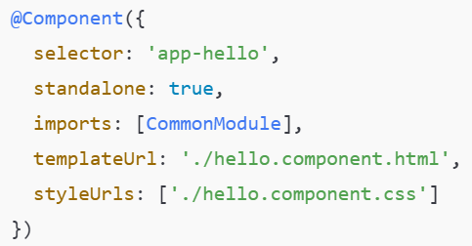
- Selector: The <name/> we use when rendering the component onto the page.
- Standalone: Not required as of Angular 19 - standalone is now default.
- Imports: Any libraries or components to be used in this component.
- templateUrl: The HTML file (AKA the template) associated with this component.
- styleUrls: Any stylesheets used in this component. This lets you directly style an individual component

Webpack (a bit about how Angular is working under the hood)

- Webpack is a powerful static module bundler for JS applications that packages all modules in our application into a bundle and serves it to the browser.
  - This is used by Angular after the TS files have been transpiled into JS. Angular uses Webpack as a dependency, but Webpack is not specific to Angular and is used in many other applications
  - “Webpack is used in the compiling/rendering process to bundle all the transpiled JS attached to our Single Page Application that gets returned to the client”
- In previous web applications we would use many JS files added to the HTML pages with <script> tags. For each user request, the browser loads all the scripts inside the HTML page. This is inefficient as the browser requests each script individually.
  - Big picture: Module bundlers are used to bundle together JS scripts and merge them into a single file. This can then be loaded by the browser all at once. This is why Webpack is useful! Great for application performance, after a longer frontload

Data Binding (QC will ask most of you about this)

- In Angular, data binding lets a component’s HTML and TS files communicate. In other words, data binding lets us share data between a component’s logic (TS) and its view (HTML)
  - Data binding is behind most of the functionality in our components.
- It’s called Data Binding because we “bind the data” from a component’s HTML to its TS or vice versa.

- There are TWO DIFFERENT KINDS of data binding: one-way and two-way
- One-way data binding allows us to manipulate the view (what the user sees - the HTML) through references to members of the component’s TS files. In Angular, there are three types of one way binding
  - String Interpolation (often just called interpolation) - This displays the value of a component’s TS variable as text in the HTML.
    - Syntax is two curly braces: {{var name}} in the HTML
    - E.g.
      - TS file: let myVar = ‘Ben’;
      - HTML: <p> Hello {{myVar}} </p>
      - This displays a paragraph that says “Hello Ben” on the page.
  - Property Binding - This binds values of component variables to the attributes of HTML element attributes.
    - Syntax is square brackets: [attribute] = “variable name”
      - (this is done in the HTML tag)
    - E.g. <img [src] = “image”> assume “image” is a TS variable
  - Event Binding - This allows us to bind DOM events such as button clicks, mouse overs etc, to a function in the component. Similar to how event handlers/listeners work in plain JavaScript.
    - Syntax is parenthesis: (event) = “function name”
      - (this is done in the HTML tag)
    - E.g. <input type=”submit” (click) = “submitFunction()”/>
  - NOTE: The curriculum mentions template statements. Put simply, a template statement is the function connected to an event binding.

- Two-way Binding combines property binding and event binding together. It is very useful for collecting user input!
  - Syntax is “banana in a boat”: [(ngModel)] = “variable name”
- What’s going on here? There are two different input boxes. One is bound to a TS variable called “username” while the other is bound to “password”.
  - Maybe some kind of login page?
- NOTE: Two way binding requires us to import the FormsModule in the imports section of the component before it can be used.

Angular Directives

- Angular Directives provide functionality for dynamic DOM manipulation in our HTML.
  - The directive is a marker on a DOM element (in the HTML) that tells Angular to change the appearance, behavior, and/or layout of an element and its children. Generally, they begin with “ng”. They will be your best friend when it comes to writing dynamic functionality for your webpage.
- 2 Types we’ll talk about:
  - Structural Directive: These change the structure of the DOM elements. They are declared generally with a star - *ng.
    - E.g. *ngIf, *ngFor
  - Attribute Directives: These change the look or behavior of an element. They change the ATTRIBUTES of DOM elements
    - E.g. ngModel, ngClass, ngStyle, (we’ll mostly only use ngModel)

- Examples of Structural Directives
  - *ngIf - renders an element (or not) based on a boolean expression
    - Good for conditionally rendering something on the page.
  - *ngFor - repeats a part of the HTML template for each item in an iterable list (generally an Array)
    - Good for rendering multiple things on the page.
- Examples of Attribute Directives
  - ngClass - used to change the class of an HTML element to the value of the variable/expression you associate it with.
    - E.g. [ngClass] = “someVariable”
  - ngStyle - Used to change the style attributes of an HTML element based on some value in the TS.
    - E.g. [ngStyle] = “someVariable”
- The idea is that HTML class and style attributes are easily changeable when we use ngClass or ngStyle. Instead of having to do the classic document.getElementById(), getAttribute(ClassName), THEN change the value... you can change the value based on some variable in the TS.

Example with Two Way Binding – A user is prompted to enter a username:
<input type = ‘text’ [(ngModel)] = ‘username’>
<p [ngStyle] = “{‘color’: username == ‘Admin’ ? ‘green’ : ‘blue’> Welcome! </p>
(What’s happening here? Based on the username inputted, the text color will change, thanks to ngStyle. Side note: remember two-way binding is used to take user input!)

ngSwitch - combines both attribute and structural directives

- The ngSwitch directive will create an element in the DOM based on a switch statement. (Thus changing the DOM structure).
  - The statement itself is an attribute of the element, so it’s considered both a structural and attribute directive
- ngSwitch works very much like a switch in Java! You’re building a switch statement directly into your HTML page.
  - ngSwitch - an attribute directive that links to the variable or expression on the TS file. Like the variable/expression in a Java switch statement.
  - *ngSwitchCase - a structural directive that creates an element if the ngSwitch matches the given value. Like a case in a Java switch.
  - *ngSwitchDefault - a structural directive that creates an element if the ngSwitch does not match any of the values identified by the *ngSwitchCase directives. Like the default case in a Java switch statement.

- <div [ngSwitch]="someNumber">
<p *ngSwitchCase="'1'">You entered - One</p>
<p *ngSwitchCase="'2'">You entered - Two</p>
<p *ngSwitchCase="'3'">You entered - Three</p>
<p *ngSwitchCase="'4'">You entered - Four</p>
<p *ngSwitchCase="'5'">You entered - Five</p>
<p *ngSwitchDefault> ...default </p>

</div>
- Custom directives can be created using the Angular CLI. The command is: ng generate directive <directive-name>. We won’t get into these but feel free to research.

Sharing Data between Parent and Child Components

- If you don’t plan to set up a Service (read below) for global data/function sharing, you can send data directly between parent and child with @Input and @Output.
  - @Input – Send data from a parent to a child. A value gets passed to the child when it’s rendered in the parent’s HTML.
    - (Not writing an example here cuz we’ll see this in the demo)
  - @Output – Paired with an EventEmitter object, this allows the child to emit data back to the parent.
Here’s an example of @Output between parent/child since we won’t see it in the demo:
(Note the HTML directly defined in the TS files)
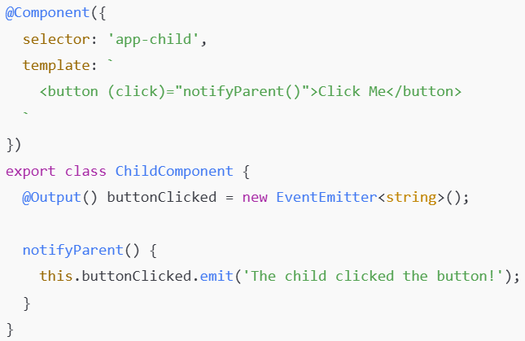

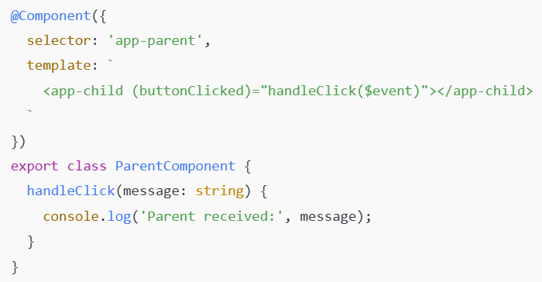
The parent renders the child component and listens for a button click
This lets the parent listen for the event that gets emitted by the child on button click.
Then, whenever the child’s button it clicked, the event gets emitted to the listening parent
*Basically, handleClick() on the parent gets invoked once notifyParent() in the child gets invoked. The parent function gets some String data from the child component’s invoked function. It’s a bit harder to wrap your head around than @Input, and less commonly used.

*End of Hello-Angular here*
Routing

- In a Single Page Application, when a request is sent to the server, only a single page is returned, as we already know.
  - However, we can emulate the experience of browsing multiple pages to the user, using routing.
  - “Routes allow for the navigation from one view to another, by changing what components are displayed.” -Nice QC line

- Go find the routes array in the app.routes.ts, we stick our components in here in order to route them and display them dynamically!
  - <---This guy

- To allow for navigation in app.routing.module, we specify objects in the routes Array. Each object will define a path and component:
  - Path - the url endpoint in the browser that we’re routing to a particular component
  - Component - is the class name of the Component we want to render.
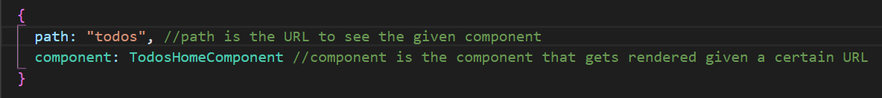
- Then we tie it all together including the <router-outlet> tag in the app.component.html. Routing won’t work if we don’t include that!
- Routing comes from the RouterModule library, which is included in modern versions of angular. We used to have to install it manually when creating a new app, with the --routing tag.

Routing Strategies (check curriculum for more details!)

- RouterLink
  - Thus far, we’ve had to manually change our URL to see different components
- But using the RouterLink attribute in our HTML elements, we can show and hide components with the click of a button
- We discovered together that href in an anchor tag achieves the same thing!
- Route Guards
  - Angular has functionality for “guarding” certain routes in our application’s routing. Essentially, routes can be labeled as only accessible to certain users.
  - Route guards exist as a way to design security into your application!

*Start of last demo - Pokemon app with HTTP requests and other tricks*

ng new pokemon-hunter --skip-git

*we’ll use bootstrap (specifically ngx-bootstrap - some guy’s recreation of bootstrap for angular* It’s really easy to use – just put this in the head of your index.html:
<!--- This is all we need to add to use NGX Boostrap - a styling framework -->
<link href="https://cdn.jsdelivr.net/npm/bootstrap@5.2.3/dist/css/bootstrap.min.css" rel="stylesheet" integrity="sha384-rbsA2VBKQhggwzxH7pPCaAqO46MgnOM80zW1RWuH61DGLwZJEdK2Kadq2F9CUG65" crossorigin="anonymous">

Here’s what it looks like
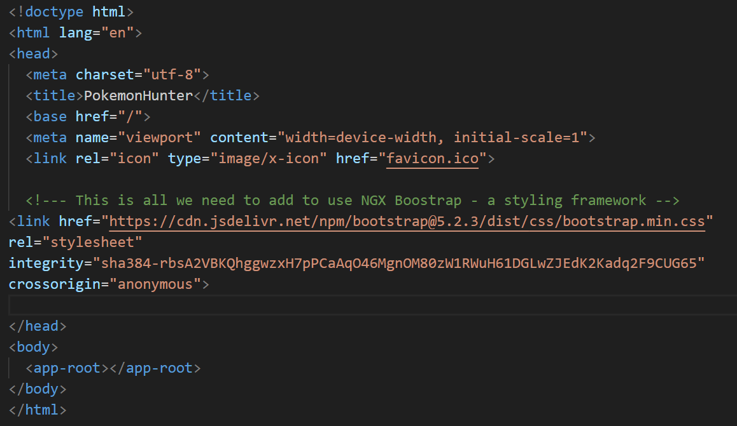

Services

- Services are used to organize and share business logic, models, data, or functions with different components of our Angular application.
  - Services play a big role in giving our components shared functionality.
- “An Angular service can be injected into multiple components, so that each component can access the fields and functions of the service.” Similar to how importing Classes works in Java.
  - This makes for very reusable code! You can inject one service into multiple components, and one component can inject many services.
  - This is what we call Dependency Injection! (DI)
  - The Injector will provide the dependencies we list in our Angular class constructors, so we don’t have to create them ourselves.

- Generating a Service with the CLI can be done easily
  - ng generate service services/<service-name>
    - OR ng g s services/<service-name>

- Services are fundamentally tied to Dependency Injection in Angular. So much so that they use the @Injectable decorator to identify them.

Dependency Injection (DI)

- Dependency Injection it’s a design pattern where the class receives its dependencies (its data/functionality) from an external source instead of creating them itself.
  - Dependency Injection does not use the “new” keyword. We declare all of the necessary members (data/functions) in one class (the service) and give them to the injectee (the component)
- Types of Dependency Injection
  - Constructor Injection: We tell our application in the constructor what dependencies we need and it will provide them when we create the object.
  - Angular used Constructor Injection exclusively til recently - we can now use field injection too! Feel free to look into that.
- Here’s a basic example of constructor injecting a Service into a Component. We then use it to populate an array of Employees

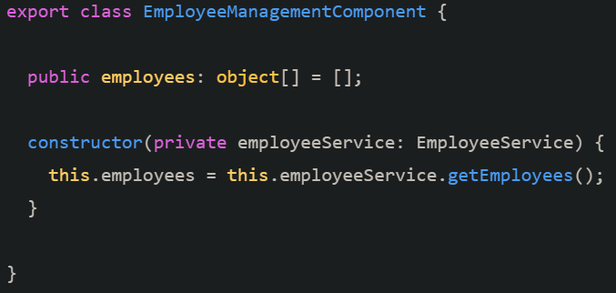

Publisher/Subscriber Design Pattern
- Pub Sub is a design pattern for sending messages between applications. We use it in our angular apps when we send HTTP requests.

- A publisher creates and pushes messages to a channel (which is basically a continuous of stream of data)
- The subscribers who subscribe to this channel/stream are immediately notified when new data gets published.
  - The subscriber then decides what to do with the message from the publisher. It will get the data the publisher is publishing, and do something with it.

- *magazine analogy* A magazine publisher constantly publishes issues of a magazine, and sends them off to the mailbox of people who have a subscription. A subscriber can get the magazine from the mailbox, and use it for whatever they wish (get information from it? do nothing with it?). A subscriber can unsubscribe at any time, and will no longer get magazines from the publisher.
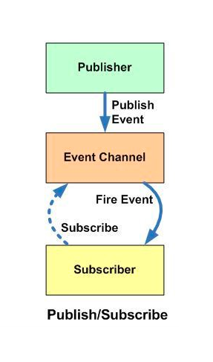

*When your phone get a push notification, that’s publisher subscriber too!

- There is a sub-design pattern called the Observable Pattern, which is what Angular uses more directly.

- 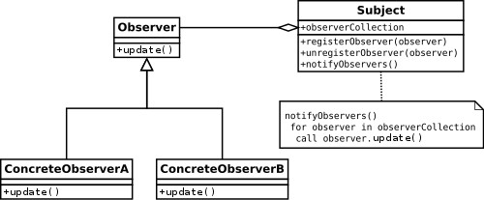

- We have a Subject (event channel) that maintains a list of Observers (subscribers). It notifies the observers of any new published messages.
- Angular uses this design pattern with the HttpClient Module (see below) to manage HTTP requests.

Observables

- Provide support for passing messages/information between parts of your application. They can be used for event handling, asynchronous programming, and handling multiple values. We will most often see them with HTTP requests.
  - Observables are the publishers in the publisher/subscriber design pattern (see above). This means our components must subscribe to an observable object in order to get information from it.
- Once you have obtained the resources you want from an observable, you can “unsubscribe” from the observable. You can do this even if you haven’t received anything from the observable.
- Observables have three callback methods happening under the hood, that we can implement ourselves if we want:
  - next() - next is called when new values enter the stream, (a new resource/message is produced). When the publisher that is being observed publishes a value, as long as it’s not an error, the observable will call this method to emit the value.
  - error() - is called if an error occurs
  - complete() - when the stream completes returning values
- Promises vs Observables? There are two major differences.
  - A promise can only emit a single value, while observables can emit many
  - Promises must return/fulfill the promise (they must complete) while observables can be unsubscribed from any time.

RxJS (Reactive Extension for JavaScript)

- “A framework for reactive programming (programming that relies on events happening) using observables that make it easier to write asynchronous code.” -nice QC line
  - This is the library we’ll be using/importing in order to use observables!!!
- RxJS Subjects are a special type of Observable that allows values to be multicast to many observables. (This just means we can send values to many places at once)
  - Look back at the diagrams - Subjects are our event channels that Observers are watching in order to get messages from Observables.
- Subjects have a notify() method that allows them to notify all the observers that are watching them.

HttpClient - Allows HTTP requests/responses in Angular

- HttpClient is a module built into Angular that provides functionality for HTTP requests and responses. (Hopefully the name makes this apparent)
  - Typed request and response object (e.g. request type, response type)
  - Built in Observables API for asynchronous coding
  - Built in error handling
  - Testing features
- Comes from (imported from) @angular/common/http
  - You will need to include the HTTPClient provider in app.config.ts to use HTTPClient!!!!
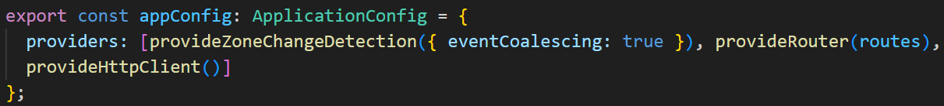
- Methods (should be recognizable)
  - request() - generic request
  - get()
  - post()
  - patch()
  - put()
  - delete()
  - head()
  - Etc.
- HttpClient has an HttpHeaders service class that is used for configuring headers of a request. You may need to look into this if you start getting CORS errors when trying to GET or POST from your Java server.
- The HttpClient, along with RxJS’s catchError function, allows easy error handling within each service that uses HttpClient.

*Used observables to get pokemon*

Angular Pipes

- Pipes provide a way to transform values in our Angular template (HTML) files.
- Pipes use the pipe character “|” and take in data to reformat it.
  - E.g. by default a date is shown in this format: Sat Aug 03 2019 19:48:11 EST+0530 (Eastern Standard Time)
  - A pipe can turn it into: Saturday, 03 Aug 2019 07:50 PM
  - Syntax: {{<var name> | <pipe name>}}
    - Eg {{name | uppercase}} //will turn “name” all uppercase
- Angular has plenty of built-in pipes. There are pipes for:
  - Date
  - Decimal
  - Currency
  - Percent
  - Lowercase/Uppercase
  - TitleCase - makes every word begin with a capital letter
  - Json
- You can create your own custom pipes too:
  - CLI command is: ng g pipe <pipe-name>
- Pipe classes use the @Pipe decorator while implementing PipeTransform.
Signals
- Signals let us listen for changes in application state and execute some code when changes occur.
  - “Application state”? Just a fancy way to say the data stored in the app at a given point in time. If a user logs in to the app, app state will change as we store that user’s info locally.

- There are two flavors of Signals:
  - Writeable – This is a Signal that we can set and update at will. Hence the name “writeable” as in “write access”.
    - We use the signal() function to create one
    - You can use set() to set the value directly
      - 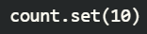
    - Or use update() to define a function that changes the value

  - Computed – This is a signal that is calculated based off other signals. We can’t update it directly.
    - We use the computed() function to create one. Here’s we’re calling back to the “count” signal from the example above
      - 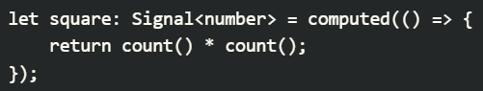
      - Now, whenever count() updates, square() will as well.

- Once we’ve written a signal, we can define some code to execute with an effect. Just call the effect() function and indicate what signal to listen for:
  - 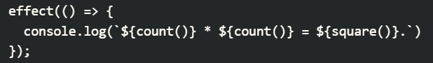
    - This effect() will log the new count/square values whenever either of them change
    - Think “side effect” of these variables changing.
- Signals are often not necessary unless you’re dealing with very time sensitive functionality like stocks or ticket sales.

Component Lifecycle Methods
- Angular components have a lifecycle defined by 9 phases a component goes through when rendered on the webpage. We can “hook” into these phases to execute code when they occur. Some examples inclulde:
- Constructor
  - Technically a component lifecycle method, this executes before any of the other lifecycle methods listed below. This is where you inject dependencies like services or import other components that need to be present before the component renders anything.
- NgOnChanges()
  - Lets you define code to get invoked whenever a component’s @Input properties change.
- NgOnIt()
  - Lets you define code to get invoked on initialization of the component. (When it first renders, after the constructor is done)
- NgAfterViewInit()
  - Lets you define code to get invoked once the component is done rendering the HTML (AKA what the user sees – the “view”)
- NgOnDestroy()
  - Lets you define code to get invoked on teardown of the component (When it gets de-rendered off the screen)

- Plus some more! Feel free to look at the curriculum for more (there are 8 total), but these are some of the main characters.

Testing in Angular - Jasmine and Karma Overview

- Jasmine and Karma are built in tools to support testing in Angular.
- Jasmine is the actual testing framework
  - Jasmine can write different types of tests, but primarily unit tests.
  - Jasmine attempts to write tests in a “human readable” way.
  - Jasmine starts by identifying the file under testing with the “describe” keyword and has a callback function to ensure all dependencies are accessible
    - E.g. describe(‘AppComponent’, callback)
  - Jasmine has beforeEach, afterEach, beforeAll, afterAll, just like JUnit
  - The actual test uses the “it” with the test name/title and a callback function that serves as the actual test function. It will include the “expect” keyword.
    - E.g it(‘should have the title “myApp”’, () => {
const appTitle = document.getElementById(“title”).value;
expect(appTitle).toEqual(“myApp”);})

- Karma is a task runner for Jasmine. It works with Jasmine by default but can be used with other frameworks if configured to do so.
  - Karma will have a configuration file that chooses the testing framework (Jasmine is the default) and other options including what browser to display in.
  - It will display reports from the tests, hot-reload the tests if changes are made, and otherwise manage the Jasmine tests (check for code coverage, etc)

